WEEK 5 COMPREHENSIVE DATA SCIENCE PROJECT REPORT

Data Science Internship – Comprehensive Project Reporting and Strategic Recommendations
Prepared By: Vasundhara Chandra
Internship: Virtual Data Science with Python Apprentice Internship
Project Duration: Weeks 1–5
Programming Language: Python
Tools: Google Colab, Pandas, NumPy, Matplotlib, Seaborn, SciPy, Statsmodels, Scikit-learn, GitHub

Table of Contents
- Executive Summary
- Introduction
- Project Objectives
- Project Overview and Synthesis
- Datasets Used
- Tools and Technologies
- Overall Methodology
- Week 1 – Titanic Exploratory Data Analysis
- Week 2 – Advanced Data Visualization
- Week 3 – Statistical Analysis and Hypothesis Testing
- Week 4 – Machine Learning Model Development and Evaluation
- Integrated Findings Across the Project
- Strategic Analysis
- Strategic Recommendations
- Potential Business Impact
- Research Outcomes
- Limitations
- Future Improvements
- Conclusion
- GitHub Repositories
- Appendix – Important Code Snippets
- References

1. Executive Summary
This report presents a comprehensive summary of the data science work completed during the five-week internship. The project integrates exploratory data analysis, data visualization, statistical analysis, hypothesis testing, regression analysis, machine learning, model evaluation, and strategic recommendation development.
The project was completed using two major datasets. The Titanic Passenger Dataset was used during Weeks 1 and 2 to perform exploratory data analysis and create meaningful visualizations. The Advertising Dataset was used during Weeks 3 and 4 for statistical analysis, hypothesis testing, regression analysis, and machine learning model development.
During the Titanic analysis, the dataset was examined for missing values, duplicates, distributions, relationships and survival patterns. The dataset contained 891 passenger records. The overall survival rate was approximately 38.38%. Female passengers had a substantially higher survival rate than male passengers. Passenger class also showed an important relationship with survival, with first-class passengers having a higher survival rate than second- and third-class passengers.
The Advertising dataset contained 200 observations involving TV, Radio, Newspaper advertising expenditure and Sales. Statistical analysis showed a strong positive relationship between TV advertising expenditure and Sales. The Pearson correlation coefficient was 0.7822, with a p-value of approximately 1.467 × 10⁻⁴², indicating a statistically significant relationship.
Machine learning models were then developed to predict Sales. Linear Regression achieved a recorded test R² of approximately 89.94%, while the Decision Tree model achieved approximately 91.45%. Therefore, the Decision Tree produced the better recorded test performance. TV advertising was the most important feature in the Decision Tree model, followed by Radio and Newspaper.
The overall project demonstrates how data science can transform raw data into meaningful insights and support evidence-based decision-making. The findings can help organizations understand patterns, evaluate relationships, predict outcomes and develop data-driven strategies.

2. Introduction
Data science is an interdisciplinary field that combines programming, statistics, mathematics, visualization and machine learning to extract useful insights from data.
The purpose of this internship was to gain practical experience with the complete data science workflow. Instead of focusing only on theoretical concepts, the project involved working with datasets, cleaning data, exploring patterns, creating visualizations, performing statistical tests and developing machine learning models.
The work was completed progressively over five weeks.
In the initial weeks, exploratory data analysis was performed on the Titanic dataset. This helped develop skills in data cleaning, descriptive statistics and visualization.
The following week focused on statistical analysis and hypothesis testing using the Advertising dataset. Correlation and regression techniques were used to investigate relationships between advertising expenditure and Sales.
The machine learning stage then extended this analysis by building predictive models for Sales.
The final week integrates all these activities into one comprehensive report and translates the analytical findings into strategic recommendations.

3. Project Objectives
The major objectives of the project were:
- To understand and analyze real-world datasets.
- To perform data cleaning and preprocessing.
- To conduct exploratory data analysis.
- To identify important patterns and relationships.
- To create meaningful data visualizations.
- To apply statistical analysis techniques.
- To formulate and test hypotheses.
- To build machine learning models.
- To evaluate and compare model performance.
- To identify important predictive features.
- To convert analytical results into actionable recommendations.
- To understand potential business impact.
- To identify limitations of the analysis.
- To suggest future improvements.
- To document the complete project professionally.

4. Project Overview and Synthesis
The project followed a progressive data science workflow.

Week 1 – Titanic Exploratory Data Analysis
The Titanic passenger dataset was explored to understand passenger characteristics and survival patterns.

Week 2 – Advanced Visualization
Additional visualizations were created to communicate relationships and patterns more effectively.

Week 3 – Statistical Analysis and Hypothesis Testing
The Advertising dataset was analyzed using descriptive statistics, correlation, hypothesis testing and regression.

Week 4 – Machine Learning Model Development
Machine learning models were developed to predict Sales using advertising expenditure variables.

Week 5 – Comprehensive Reporting
The results from all previous weeks were integrated into a single report containing strategic recommendations, business implications, limitations and future improvements.
This progression represents the complete data science lifecycle:
Data → Cleaning → EDA → Visualization → Statistics → Modeling → Evaluation → Insights → Recommendations

5. Datasets Used

5.1 Titanic Dataset
The Titanic dataset contains information about passengers who travelled on the RMS Titanic.
Important variables include:
- Passenger ID
- Survived
- Passenger Class
- Name
- Sex
- Age
- Number of siblings/spouses
- Number of parents/children
- Ticket
- Fare
- Cabin
- Embarked
The dataset was mainly used for exploratory analysis and visualization.

5.2 Advertising Dataset
The Advertising dataset contains information about advertising expenditure and Sales.
The main variables are:
Variable | Description
TV | Advertising expenditure on TV
Radio | Advertising expenditure on Radio
Newspaper | Advertising expenditure on Newspaper
Sales | Product Sales
The Advertising dataset was used for statistical analysis and machine learning.

6. Tools and Technologies
The following tools and technologies were used:

Python
Python was used as the primary programming language.

Pandas
Used for:
- Data loading
- Data cleaning
- Data manipulation
- Grouping
- Descriptive statistics

NumPy
Used for numerical operations.

Matplotlib
Used for creating graphs and charts.

Seaborn
Used for statistical visualization.

SciPy
Used for statistical tests such as Pearson correlation and Shapiro-Wilk testing.

Statsmodels
Used for statistical regression analysis and model summaries.

Scikit-learn
Used for machine learning model development and evaluation.

Google Colab
Used as the development and analysis environment.

GitHub
Used for project version control and storing project files.

7. Overall Methodology
The project followed these major steps:

Step 1 – Data Collection
Publicly available datasets were collected and loaded into Python.

Step 2 – Data Inspection
The datasets were inspected using:
df.head()
df.shape
df.info()
df.describe()

Step 3 – Data Cleaning
Missing values, duplicate records and unnecessary columns were identified and handled.

Step 4 – Exploratory Data Analysis
Descriptive statistics and group-based analysis were performed.

Step 5 – Visualization
Charts such as bar plots, histograms, boxplots, scatter plots and heatmaps were created.

Step 6 – Statistical Analysis
Correlation and regression analysis were performed.

Step 7 – Hypothesis Testing
Statistical hypotheses were formulated and tested.

Step 8 – Machine Learning
Regression models were trained using the Advertising dataset.

Step 9 – Model Evaluation
Models were evaluated using metrics such as:
- MAE
- MSE
- RMSE
- R²

Step 10 – Strategic Interpretation
The analytical findings were converted into recommendations.

8. Week 1 – Titanic Exploratory Data Analysis

8.1 Data Understanding
The Titanic dataset contained 891 records.
The dataset was initially examined to understand its structure, variable types and missing values.
The following Python commands were used:
df.head()
df.shape
df.info()
df.describe()
df.isnull().sum()

8.2 Data Cleaning
Missing values were identified and handled during preprocessing.
Duplicate records were also checked.
df.isnull().sum()
df.duplicated().sum()
After preprocessing, the dataset was suitable for exploratory analysis.

8.3 Survival Analysis
The overall survival rate was approximately:
38.38%
This means that fewer than half of the passengers in the dataset survived.

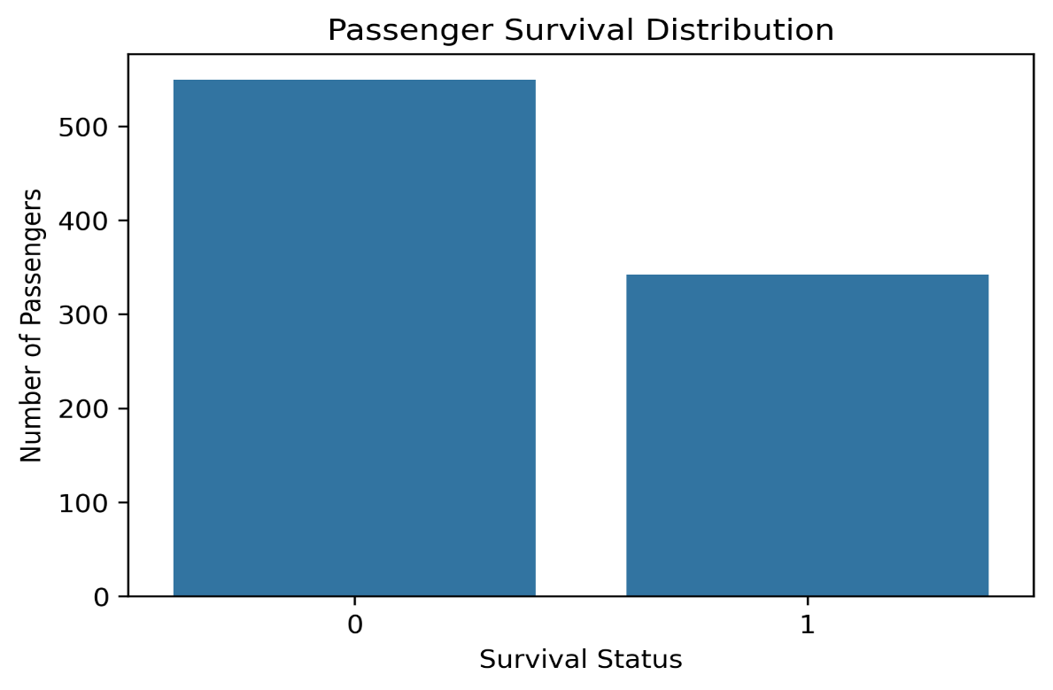
Figure 1 – Titanic Survival Distribution
Explanation:
The chart shows the number and proportion of passengers who survived and did not survive.

8.4 Survival by Gender
Gender was one of the most noticeable factors in the exploratory analysis.
Approximately:
- Female survival rate: 74.20%
- Male survival rate: 18.89%
This indicates a large difference in survival outcomes between the two groups.

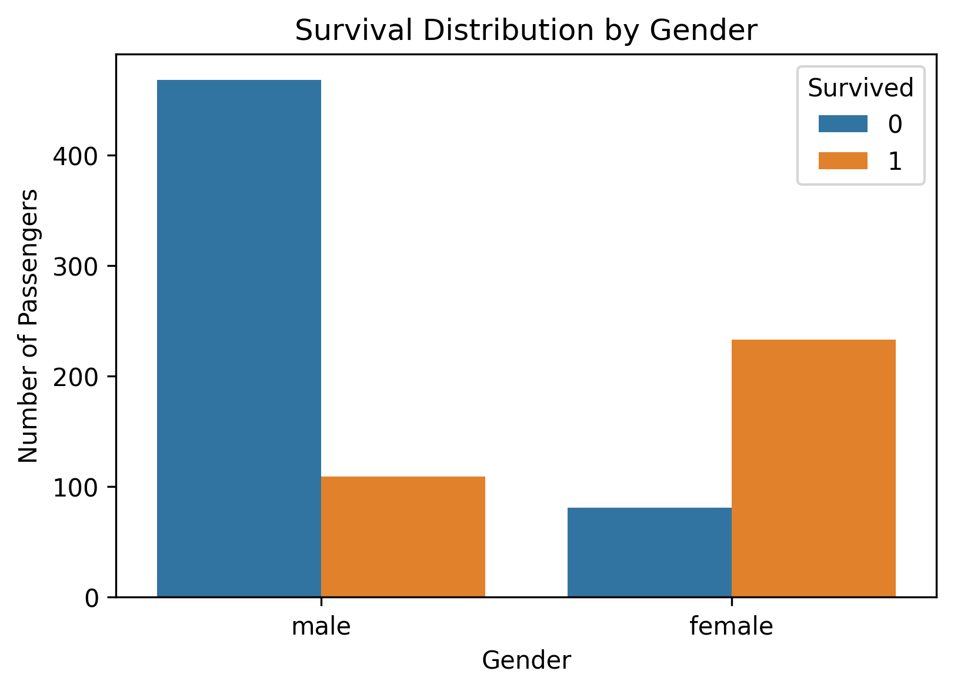
Figure 2 – Survival Rate by Gender
Explanation:
The visualization compares survival percentages between male and female passengers.

8.5 Survival by Passenger Class
Passenger class also showed a clear difference.
Approximate survival rates:
- First Class: 62.96%
- Second Class: 47.28%
- Third Class: 24.24%
The analysis suggests that passengers in higher classes had higher survival rates.

8.6 Age Analysis
The mean age of survivors was approximately 28.29 years, while the mean age of non-survivors was approximately 30.03 years.
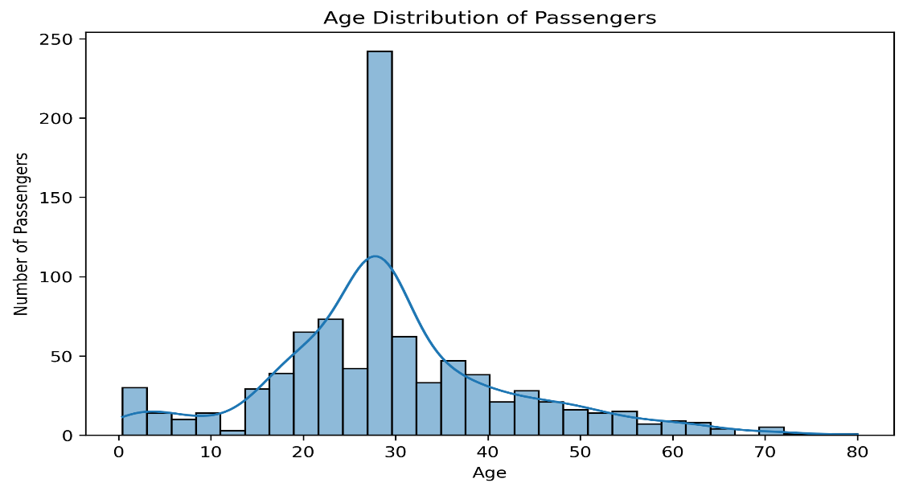
Figure 4 – Age Distribution

8.7 Fare Analysis
Fare distributions were examined using boxplots to identify differences and possible outliers.

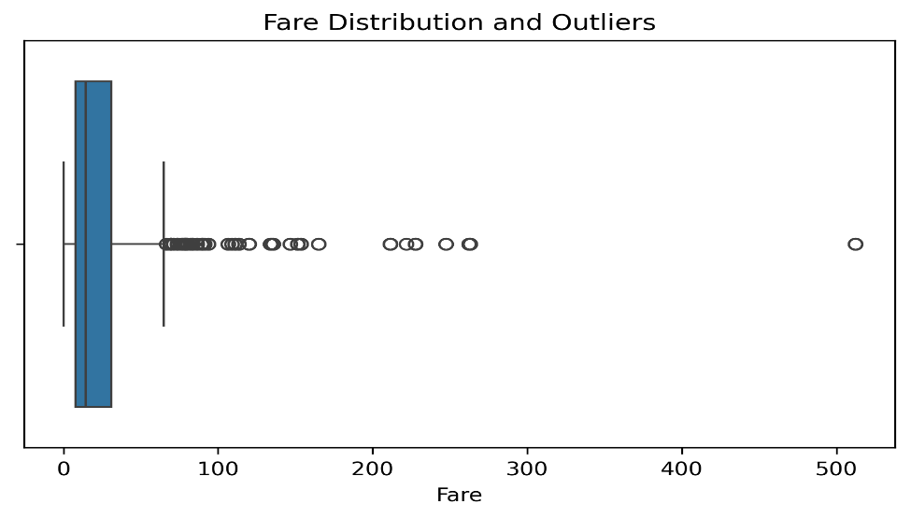
Figure 5 – Fare Distribution / Boxplot

9. Week 2 – Advanced Data Visualization
Visualization played an important role in communicating the findings.
Different visualization techniques were used to understand:
- Categorical relationships
- Numerical distributions
- Group differences
- Correlations
- Outliers
Important visualizations included:
- Bar charts
- Histograms
- Boxplots
- Heatmaps
- Comparative charts

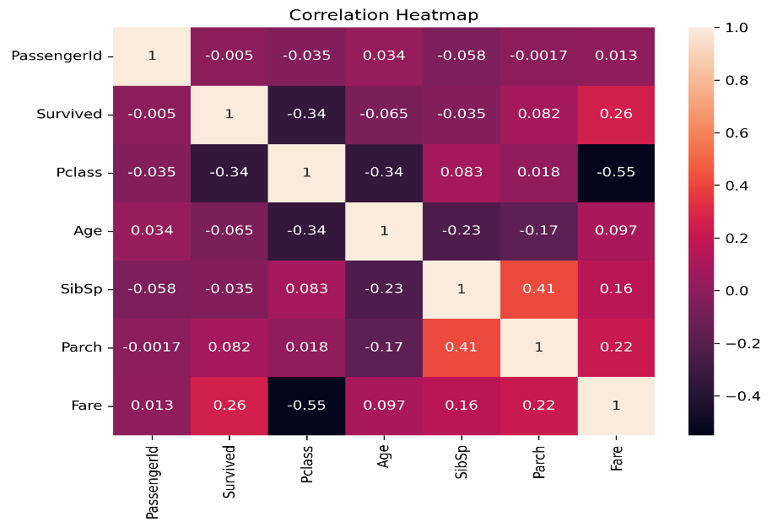
Figure 6 – Correlation Heatmap

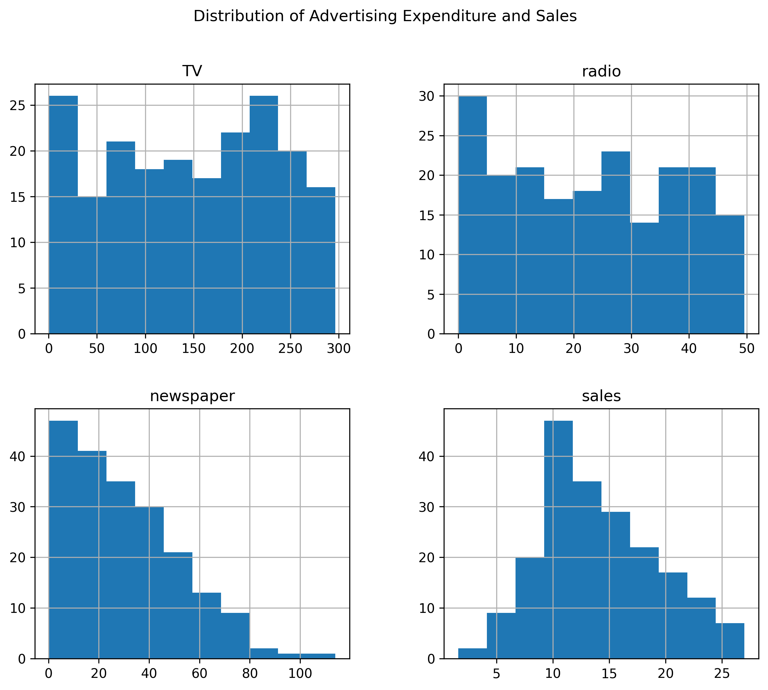
Figure 7 – Advanced Comparative Visualization
Importance of Visualization
Data visualization makes complex numerical information easier to understand.
For example, a survival percentage in a table provides a number, while a bar chart immediately shows the difference between groups.
Therefore, visualization supports both technical analysis and communication with non-technical stakeholders.

10. Week 3 – Statistical Analysis and Hypothesis Testing
The Advertising dataset was used for statistical analysis.

10.1 Research Question
The main research question was:
Is there a statistically significant relationship between TV advertising expenditure and Sales?

10.2 Hypothesis

Null Hypothesis – H₀
There is no statistically significant relationship between TV advertising expenditure and Sales.

Alternative Hypothesis – H₁
There is a statistically significant relationship between TV advertising expenditure and Sales.

10.3 Pearson Correlation
Pearson correlation was calculated between TV advertising expenditure and Sales.
The result was:
Correlation = 0.7822
This indicates a strong positive relationship.
The p-value was approximately:
1.467 × 10⁻⁴²
Since:
p-value < 0.05
the null hypothesis was rejected.
Therefore, the analysis provides strong statistical evidence of a positive relationship between TV advertising expenditure and Sales.

Code:
from scipy.stats import pearsonr

correlation, p_value = pearsonr(
df["TV"],
df["Sales"]
)

print(correlation)
print(p_value)

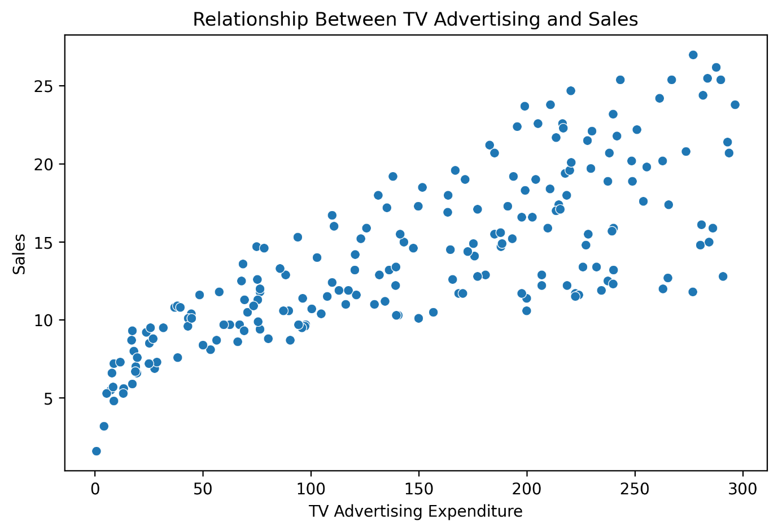
Figure 8 – TV Advertising vs Sales Scatter Plot

10.4 Simple Linear Regression
A simple linear regression model was developed using TV advertising expenditure as the independent variable and Sales as the dependent variable.
The model produced an R² of approximately:
0.612
This means approximately 61.2% of the variation in Sales was explained by TV advertising expenditure in the simple regression model.
The estimated coefficient for TV was approximately:
0.0475
The approximate 95% confidence interval was:
0.042 to 0.053

Insert Image Here:
Figure 9 – Regression Line

10.5 Regression Diagnostics
Diagnostic analysis was performed to check assumptions.
The Shapiro-Wilk test produced a p-value of approximately:
0.2133
This did not provide evidence against normality at the 5% significance level.
The Durbin-Watson statistic was approximately:
1.935
which is close to 2 and therefore does not indicate a strong autocorrelation problem.

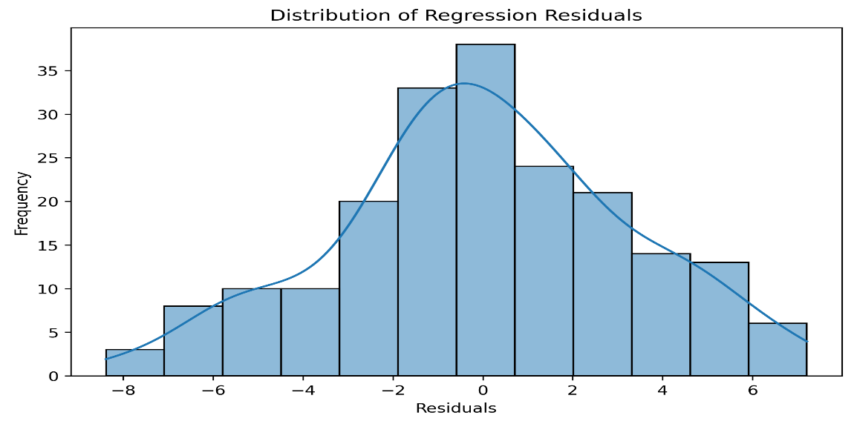
Figure 10 – Residual Distribution

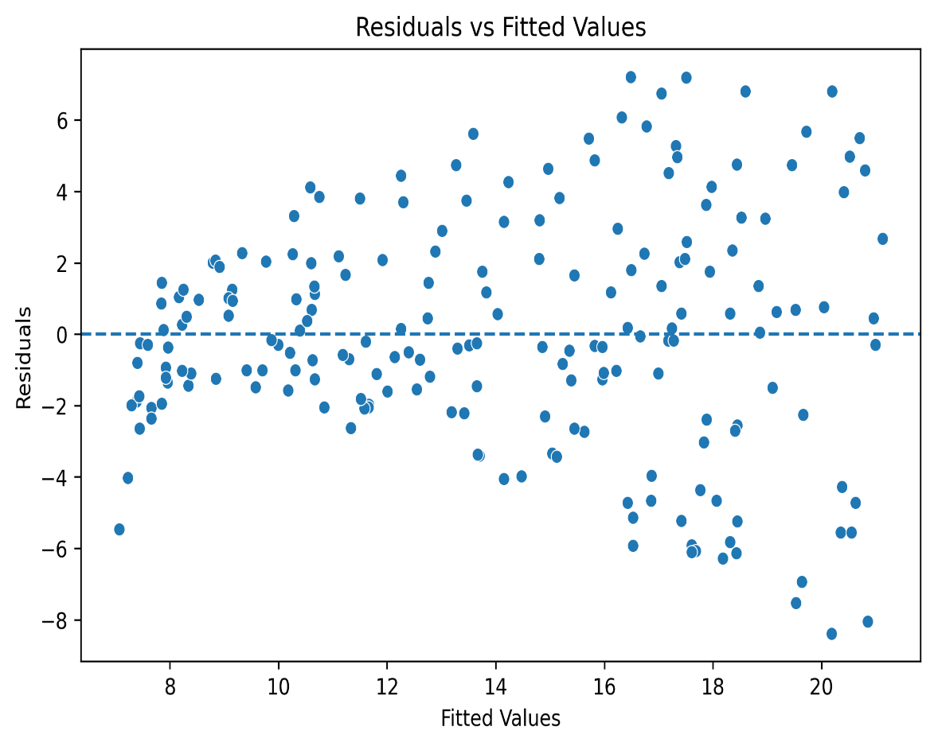
Figure 11 – Residual Plot

11. Week 4 – Machine Learning Model Development and Evaluation
The Advertising dataset was used to build predictive models.
The target variable was:
Sales
The input features were:
- TV
- Radio
- Newspaper

11.1 Data Preparation
The dataset was divided into training and testing sets.
X = df[["TV", "Radio", "Newspaper"]]
y = df["Sales"]

X_train, X_test, y_train, y_test = train_test_split(
X,
y,
test_size=0.20,
random_state=42
)

11.2 Linear Regression Model
Linear Regression was used as a baseline model.
Recorded performance:
- MAE: 1.4608
- MSE: 3.1741
- RMSE: 1.7816
- R²: 0.8994
An improved recorded evaluation was also obtained:
- MAE: 1.19435
- MSE: 2.69736
- RMSE: 1.64236
- R²: 0.91454

11.3 Feature Coefficients
The recorded Linear Regression coefficients were:
Feature | Coefficient
TV | 0.04473
Radio | 0.189195
Newspaper | 0.002761
The coefficients indicate how the predicted Sales changes with the corresponding feature while the other variables are held constant within the model.

11.4 Decision Tree Regression
A Decision Tree Regressor was also developed.
The recorded test R² was:
0.91454
or approximately:
91.45%
This was higher than the recorded Linear Regression test R² of approximately 89.94%.
Therefore, the Decision Tree was selected as the better-performing model among the evaluated models based on the recorded test R².

11.5 Feature Importance
The Decision Tree feature importance values were approximately:
Feature | Importance
TV | 61.12%
Radio | 37.76%
Newspaper | 1.12%
TV was therefore the most important feature in the model.

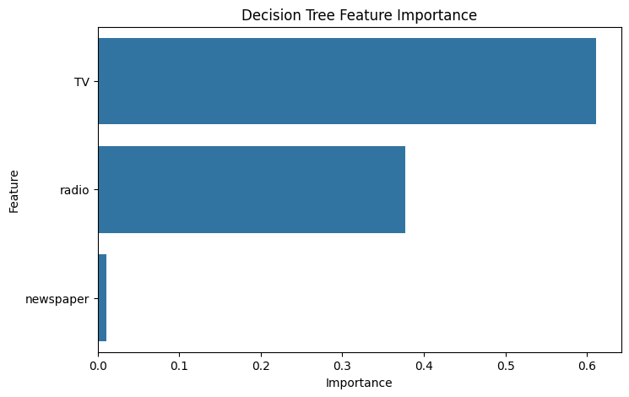
Figure 12 – Feature Importance

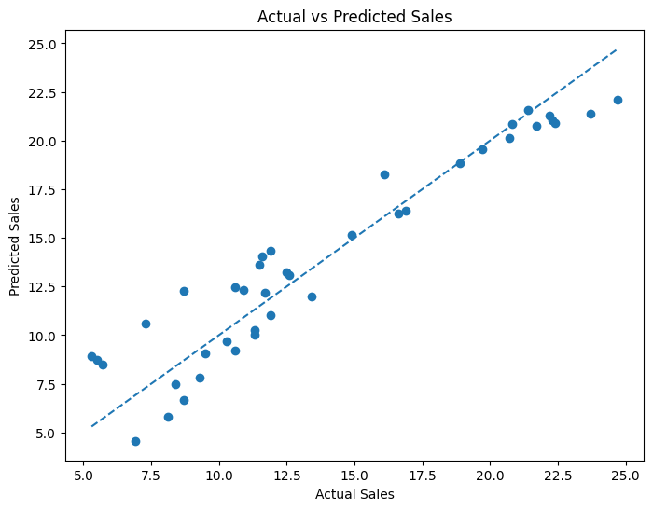
Figure 13 – Actual vs Predicted Sales

12. Integrated Findings Across the Project
The combined project produced several important findings.

Finding 1 – Data quality is important
Data cleaning was necessary before performing reliable analysis.

Finding 2 – Visualization reveals patterns
The Titanic analysis demonstrated that visualizations can clearly show differences between groups.

Finding 3 – Gender was strongly associated with Titanic survival
Female passengers had a much higher survival rate than male passengers.

Finding 4 – Passenger class was associated with survival
First-class passengers had a higher survival rate than passengers in lower classes.

Finding 5 – TV advertising has a strong positive relationship with Sales
The Pearson correlation was:
0.7822

Finding 6 – The relationship was statistically significant
The p-value was extremely small:
≈ 1.467 × 10⁻⁴²

Finding 7 – Machine learning produced strong predictive performance
The recorded Decision Tree test R² was approximately:
91.45%

Finding 8 – TV was the strongest predictive feature
TV had approximately:
61.12% feature importance

13. Strategic Analysis
The purpose of data analysis should not end with identifying statistical results. The findings should be converted into information that can support decision-making.
The Advertising analysis provides an example of how data can support marketing decisions.
The strong relationship between TV advertising and Sales indicates that TV expenditure contains substantial predictive information about Sales.
Radio also contributed meaningfully to the model.
Newspaper advertising showed comparatively low feature importance in the Decision Tree model.
However, these results should not be interpreted as proof that increasing TV expenditure automatically causes Sales to increase. Correlation and predictive importance do not by themselves establish causality.
Therefore, business decisions should combine model results with:
- Budget constraints
- Customer behavior
- Market conditions
- Competitor activity
- Pricing
- Seasonality
- Campaign quality

14. Strategic Recommendations

Recommendation 1 – Use Data-Driven Advertising Allocation
Organizations should use historical advertising and Sales data when deciding how to distribute marketing budgets.
Rather than relying only on assumptions, managers can use analytical models to estimate expected outcomes.

Recommendation 2 – Give Greater Attention to High-Value Features
TV was the strongest feature in the Decision Tree model.
Therefore, TV advertising should receive careful attention when planning future campaigns.
However, budget allocation should still be evaluated using cost-effectiveness rather than feature importance alone.

Recommendation 3 – Monitor Radio Advertising
Radio was the second most important feature in the model.
Organizations should continue monitoring its contribution and evaluate whether combining TV and Radio produces better outcomes.

Recommendation 4 – Do Not Ignore Other Business Variables
The current dataset contains only a limited number of variables.
Future analysis should include variables such as:
- Product price
- Discounts
- Promotions
- Competitor spending
- Customer demographics
- Seasonality
- Market size
This could improve prediction quality.

Recommendation 5 – Continuously Update the Model
The predictive model should not be treated as a one-time solution.
As new Sales and advertising data become available, the model should be retrained and evaluated.

Recommendation 6 – Use Dashboards for Decision-Making
An interactive dashboard could present:
- Advertising expenditure
- Predicted Sales
- Actual Sales
- Model performance
- Feature importance
- Historical trends
This would make the analysis more accessible to managers and stakeholders.

15. Potential Business Impact
The project demonstrates several potential business benefits.

15.1 Better Marketing Decisions
Marketing teams can use predictive analytics to understand relationships between advertising investment and Sales.

15.2 Improved Budget Planning
Predictive models can support advertising budget planning by estimating expected Sales.

15.3 Reduced Decision-Making Based on Guesswork
Data-driven analysis provides quantitative evidence for business decisions.

15.4 Early Identification of Important Variables
Feature importance can help organizations identify which variables deserve further investigation.

15.5 Improved Monitoring
Comparing predicted Sales with actual Sales can help organizations detect changes in business performance.

16. Research Outcomes
From a research perspective, the project demonstrates the complete analytical process.
The major research outcomes are:
- Identification of patterns through EDA.
- Quantification of relationships through correlation.
- Statistical validation through hypothesis testing.
- Prediction through machine learning.
- Comparison of alternative models.
- Identification of important predictive features.
- Translation of analytical results into recommendations.
The project also demonstrates that statistical analysis and machine learning serve different purposes.
Statistical analysis helps answer questions about relationships and significance, while machine learning primarily focuses on prediction.

17. Limitations
Despite producing useful findings, the project has several limitations.

17.1 Dataset Size
The Advertising dataset contains only 200 observations.
A larger dataset could provide more reliable and generalizable results.

17.2 Limited Variables
The Advertising dataset does not contain variables such as:
- Pricing
- Promotions
- Competition
- Seasonality
- Customer demographics
These factors may influence Sales.

17.3 Correlation Does Not Mean Causation
The positive relationship between TV advertising and Sales does not prove that TV advertising alone caused the increase in Sales.

17.4 Historical Titanic Data
The Titanic dataset represents a historical event and its findings cannot automatically be generalized to modern situations.

17.5 Model Dependence
Decision Tree feature importance depends on the selected model and dataset.

17.6 Train-Test Split
Machine learning performance can vary depending on the training and testing split.

17.7 Limited Model Comparison
Additional algorithms could be evaluated to determine whether better predictive performance is possible.

18. Future Improvements
Future work can improve the project in several ways.

1. Larger Dataset
Collect more observations to improve reliability.

2. Cross-Validation
Use k-fold cross-validation for more robust model evaluation.

3. Hyperparameter Tuning
Optimize Decision Tree parameters such as:
- max_depth
- min_samples_split
- min_samples_leaf

4. Advanced Models
Compare:
- Random Forest
- Gradient Boosting
- Random Forest Regressor
- XGBoost, where appropriate

5. Feature Engineering
Create additional meaningful features and interaction variables.

6. Interactive Dashboard
Build a dashboard using:
- Streamlit
- Power BI
- Tableau

7. Automated Reporting
Develop a system that automatically generates analytical reports when new data is uploaded.

8. Model Monitoring
Continuously compare predicted and actual Sales.

19. Conclusion
This comprehensive project successfully integrated the major concepts learned during the five-week Data Science internship.
The project started with exploratory analysis of the Titanic dataset and progressed toward advanced visualization, statistical analysis, hypothesis testing and machine learning.
The Titanic analysis identified important survival patterns. The overall survival rate was approximately 38.38%, while female passengers and passengers in higher classes showed higher survival rates.
The Advertising analysis demonstrated a strong positive relationship between TV advertising expenditure and Sales. The Pearson correlation coefficient was 0.7822 and the relationship was statistically significant.
Machine learning extended the analysis into prediction. The recorded Decision Tree model achieved a test R² of approximately 91.45%, outperforming the recorded Linear Regression test R² of approximately 89.94%.
TV was the most important feature in the Decision Tree model, followed by Radio.
Most importantly, the project demonstrates that data science is not limited to creating models. A successful data science project requires understanding the data, identifying meaningful patterns, validating findings statistically, evaluating predictive performance and communicating actionable recommendations.
The overall workflow can therefore be summarized as:
Collect → Clean → Explore → Visualize → Analyze → Model → Evaluate → Recommend
This project provided practical experience in each of these stages and established a strong foundation for future data science projects.

20. GitHub Repositories

Week 1 + Week 2 – Titanic EDA and Advanced Visualization
GitHub:
https://github.com/vashuchandra08-tech/week-1-titanic-eda

Week 3 – Statistical Analysis and Hypothesis Testing
GitHub:
https://github.com/vashuchandra08-tech/statistical-analysis-hypothesis-testing

Week 4 – Machine Learning Model Development
GitHub:
https://github.com/vashuchandra08-tech/machine-learning-model-development
Week 5 – Final Comprehensive Report
GitHub:
https://github.com/vashuchandra08-tech/data-science-comprehensive-report
- Word report
- README
- Selected visualizations
- Important notebooks/code
- Project documentation

21. Appendix – Important Code Snippets

Loading Dataset
import pandas as pd

df = pd.read_csv("Advertising.csv")

df.head()
df.info()
df.describe()

Checking Missing Values
df.isnull().sum()

Checking Duplicates
df.duplicated().sum()

Titanic Survival Rate
survival_rate = df["Survived"].mean() * 100
print(survival_rate)

Survival by Gender
gender_survival = df.groupby("Sex")["Survived"].mean() * 100
print(gender_survival)

Pearson Correlation
from scipy.stats import pearsonr

correlation, p_value = pearsonr(
df["TV"],
df["Sales"]
)

print("Correlation:", correlation)
print("P-value:", p_value)

Linear Regression
from sklearn.linear_model import LinearRegression

model = LinearRegression()

model.fit(X_train, y_train)

predictions = model.predict(X_test)

Model Evaluation
from sklearn.metrics import (
mean_absolute_error,
mean_squared_error,
r2_score
)

mae = mean_absolute_error(y_test, predictions)
mse = mean_squared_error(y_test, predictions)
rmse = mse ** 0.5
r2 = r2_score(y_test, predictions)

print(mae)
print(mse)
print(rmse)
print(r2)

Decision Tree
from sklearn.tree import DecisionTreeRegressor

tree = DecisionTreeRegressor(
random_state=42
)

tree.fit(X_train, y_train)

predictions = tree.predict(X_test)

22. References
- Python Documentation
- Pandas Documentation
- NumPy Documentation
- Matplotlib Documentation
- Seaborn Documentation
- SciPy Documentation
- Statsmodels Documentation
- Scikit-learn Documentation
- Titanic Dataset
- Advertising Dataset
- Project GitHub repositories

